Pending
Copeland Elementary
PBIS
Handbook


Copeland Wildcats Are:
Principled
Caring
Reflective

Introduction
What is PBIS  - Definition  - Multi-tiered Support | Pgs. 1-4
The 22-23 School PBIS Team  - Team Members & Role Descriptions | Pg. 5
Behavioral Expectations  - Copeland Elementary School-Wide Expectation Matrix  - Lesson Plans | Pg. 6 - 18
System for Acknowledging Behavior  - Acknowledgement Guidelines  - PBIS Points  - PBIS Monthly Celebration  - PBIS Wildcat Store | Pg. 19 - 21
System for Correcting Behavior  - PBIS: Correcting Behavior Flow Chart  - PBIS Discipline Referral  - PBIS & School Culture | Pg. 22 - 24
References | Pg. 25
Contents:

What is PBIS? Positive Behavioral Interventions and Supports (PBIS) is an evidence-based three-tiered framework to improve and integrate all of the data, systems, and practices affecting student outcomes every day.

Five Elements
PBIS emphasizes five inter-related elements: equity, systems, data, practices, and outcomes.
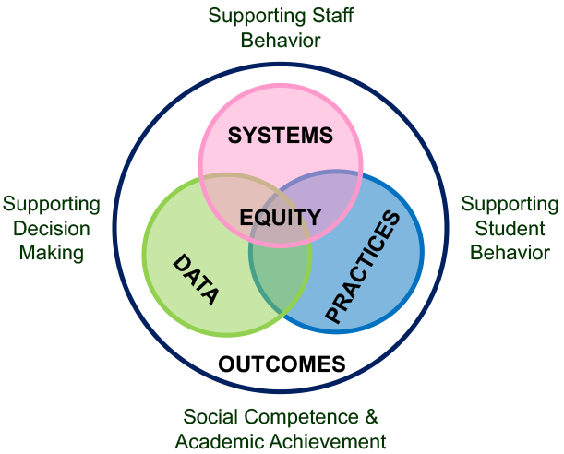

Equity
When you implement PBIS with fidelity, it fits seamlessly within your local context. To do that requires a focus on aspects of culture and equity. Leadership teams work with members of the school or program community — students, families, and community members — to prioritize valued outcomes and promote high expectations for all students. Centering equity also means supporting educators’ roles in implementation, adapting practices to meet students’ individual needs, and disaggregating data by student group to ensure success for everyone.
As you think about equity in your PBIS implementation, ask yourself: How can we enhance the experiences and outcomes of each educator and student?

Systems
Your foundational systems establish the way your schools and programs operate. Systems include teaming structures, training, coaching, and other supports for educators. In PBIS, these systems support accurate, durable implementation of practices and the effective use of data to achieve better outcomes.
As you think about the systems supporting your PBIS framework, ask yourself:
‍What can we do to sustain our implementation over the long haul?

Data
Your school or program generates a wide range of data about your students every day. Within the PBIS framework, teams use data to select, monitor, and evaluate outcomes, practices, and systems across all three tiers.
As you think about the data available to you, ask yourself:
‍What information do we need to make effective decisions about our PBIS implementation and outcomes?

Practices
The school and classroom practices you implement are critical to supporting students and creating a positive school climate. In PBIS, these interventions and strategies are backed by research and target the outcomes you and your community want to achieve.
As you think about the evidence-based practices you implement, ask yourself:
‍How will we support our students’ behavioral, social, emotional, and academic growth?

Outcomes
The ultimate goal of implementing PBIS data, systems, and practices is to improve outcomes. Families, students, and educators set goals and work together to achieve them. In PBIS, outcomes might include behavioral, social, emotional, and academic growth; positive school climate; or fewer office discipline referrals.
As you think about the outcomes you want to achieve, ask yourself:
‍What is important to each of our communities?

Tiered PBIS Framework
Educators and practitioners provide a continuum of academic, behavioral, social, and emotional support matched to students’ needs. We describe this continuum across three tiers of support.
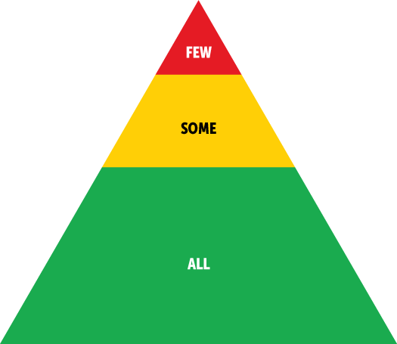
Foundational systems across all three tiers include:
- A shared vision for a positive school social culture
- A representative leadership team that meets regularly and shares expertise in coaching, social, emotional, behavioral, academic, equity, mental health, physical health, wellness, and trauma
- Families are actively engaged‍
- A supportive and involved school administration
- On-going access to professional development for preparing all staff to implement each tier of PBIS
- Systematic collection of screening, progress-monitoring, outcome, and fidelity data
- Ongoing use of data for decision making
- Disaggregating data to examine equity among student subgroups

Tier 1: Universal, Primary Prevention (All)
Tier 1 systems, data, and practices support everyone – students, educators, and staff – across all school settings. They establish a foundation for positive and proactive support. Tier 1 support is robust, differentiated, and enables most (80% or more) students to experience success. Tier 1 practices include:
- Collaborating with students, families, and educators to define positive school/program-wide expectations and prioritize appropriate social, emotional, and behavioral skills
- Aligning classroom expectations with school/program-wide expectations
- Explicitly teaching expectations and skills to set all students up for success
- Encouraging and acknowledging expected behavior
- Preventing and responding to unwanted behavior in a respectful, instructional manner
- Fostering school/program-family partnerships

Tier 2: Targeted, Secondary Prevention (Some)
In addition to your Tier 1 foundation, students receiving Tier 2 supports get an added layer of systems, data, and practices targeting their specific needs. On average, about 10-15% of your students will need some type of Tier 2 support. The support you provide at Tier 2 is more focused than at Tier 1 and less intensive than at Tier 3. Tier 2 practices include:
- Providing additional instruction and practice for behavioral, social, emotional, and academic skills
- Increasing adult support and supervision
- Providing additional opportunities for positive reinforcement
- Increasing prompts or reminders
- Increasing access to academic supports
- Increasing school-family communication

Tier 3: Intensive and Individualized, Tertiary Prevention (Few)
At most schools and programs, there are a small number (1-5%) of students for whom Tier 1 and Tier 2 supports have not been sufficient to experience success. At Tier 3, students receive more intensive, individualized support to improve their outcomes. Tier 3 supports are available to any student with intensive need, whether they receive special education services or not. Tier 3 practices include:
- Engaging students, educators, and families in functional behavioral assessments and intervention planning
- Coordinating support through wraparound and person-centered planning
- Implementing individualized, comprehensive, and function-based support

2022 – 2023 PBIS Team Members:

Dr. Laurie Taylor | Principal
Ms. Jovanghn Parks | Assistant Principal
Mrs. Nicole Atkinson | Counselor/Team Lead
Ms. Vanessa Ferguson, EIP Teacher | Coach
Ms. Victoria Brown, Special Education Teacher | Recorder/Reporter
Ms. Wendy Walker, Special Education Teacher | Behavior Specialist
Ms. Laketra Martin | Data Collection Analyst
Mrs. Tonya Simmons | MTSS

Behavioral Expectations:
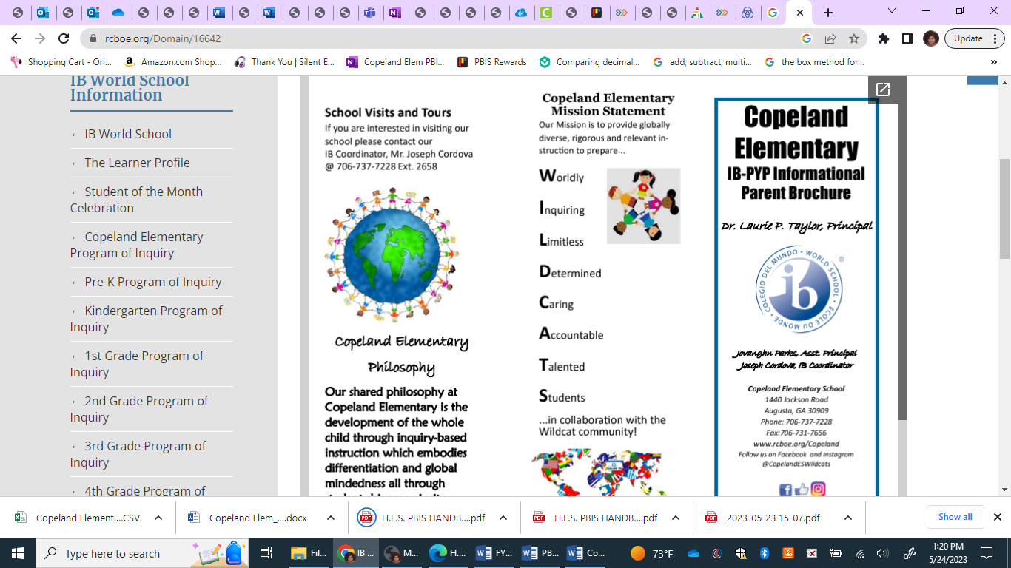
Copeland Elementary has three behavioral expectations for our school. Copeland Wildcats are: Principled, Caring, and Reflective. These three expectations are valued here at Copeland Elementary. The students at CES are principled, caring, and reflective. This will aid them to be:
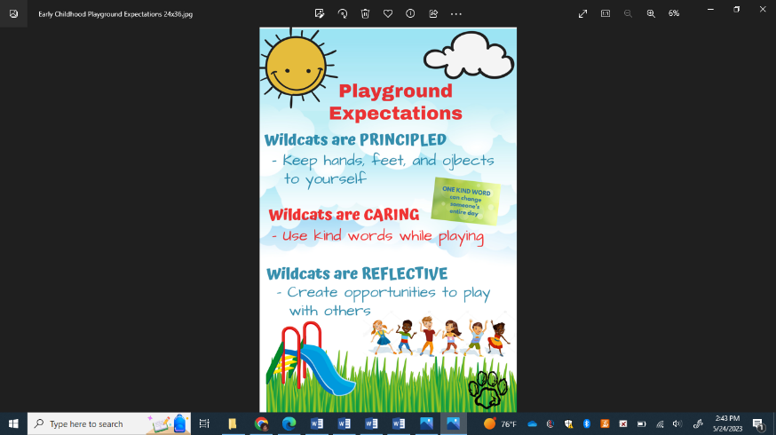
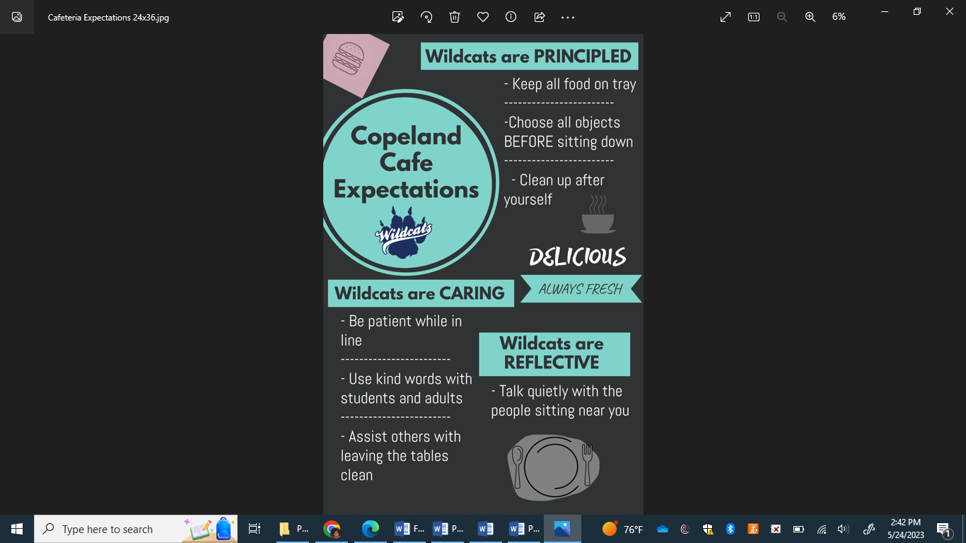
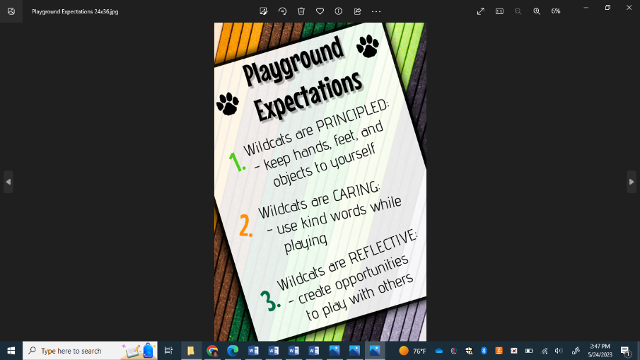
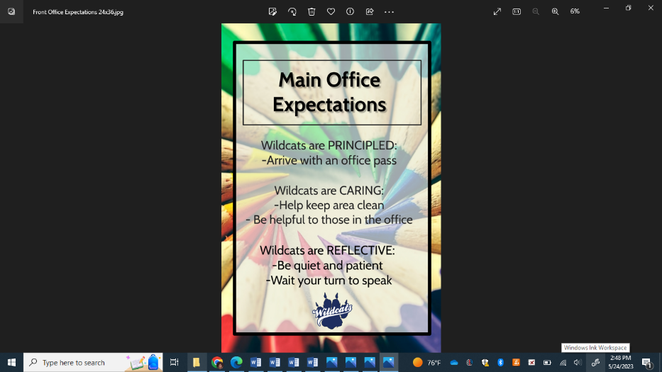

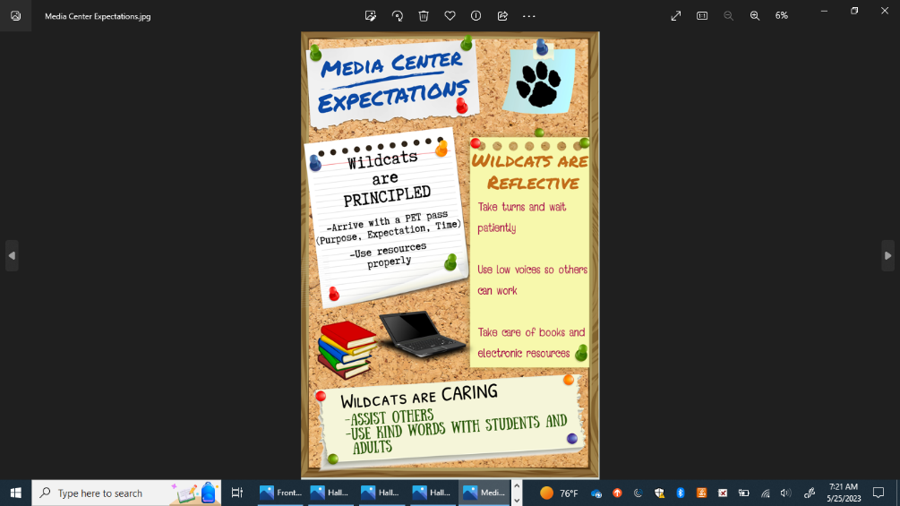

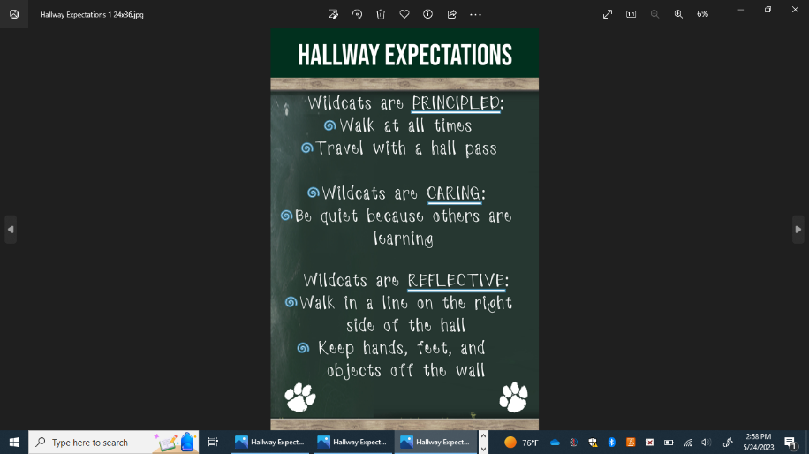
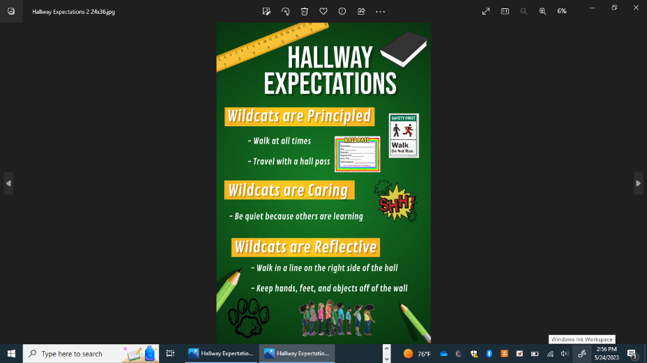

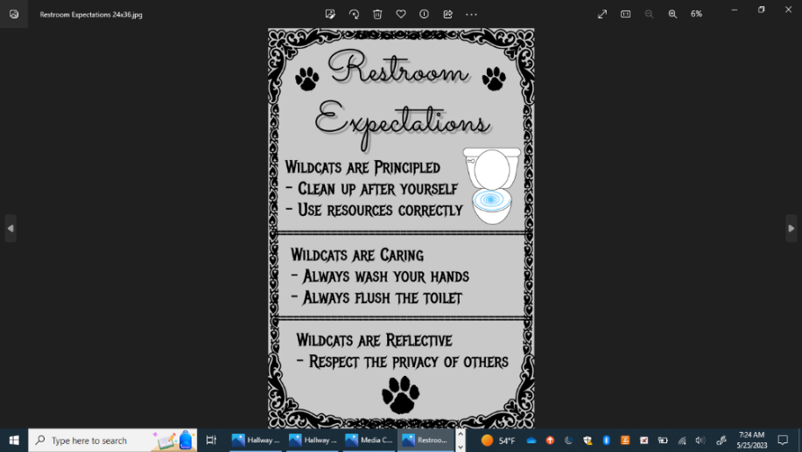

Behavior Matrix:
The PBIS Matrix is a table that breaks down our school-wide expectations into practical applications for everyday use. The matrix is supposed to leave no doubt as to what behaviors are expected in all settings throughout the CES building (hallway, bathrooms, front office, media center, cafeteria, and playground).

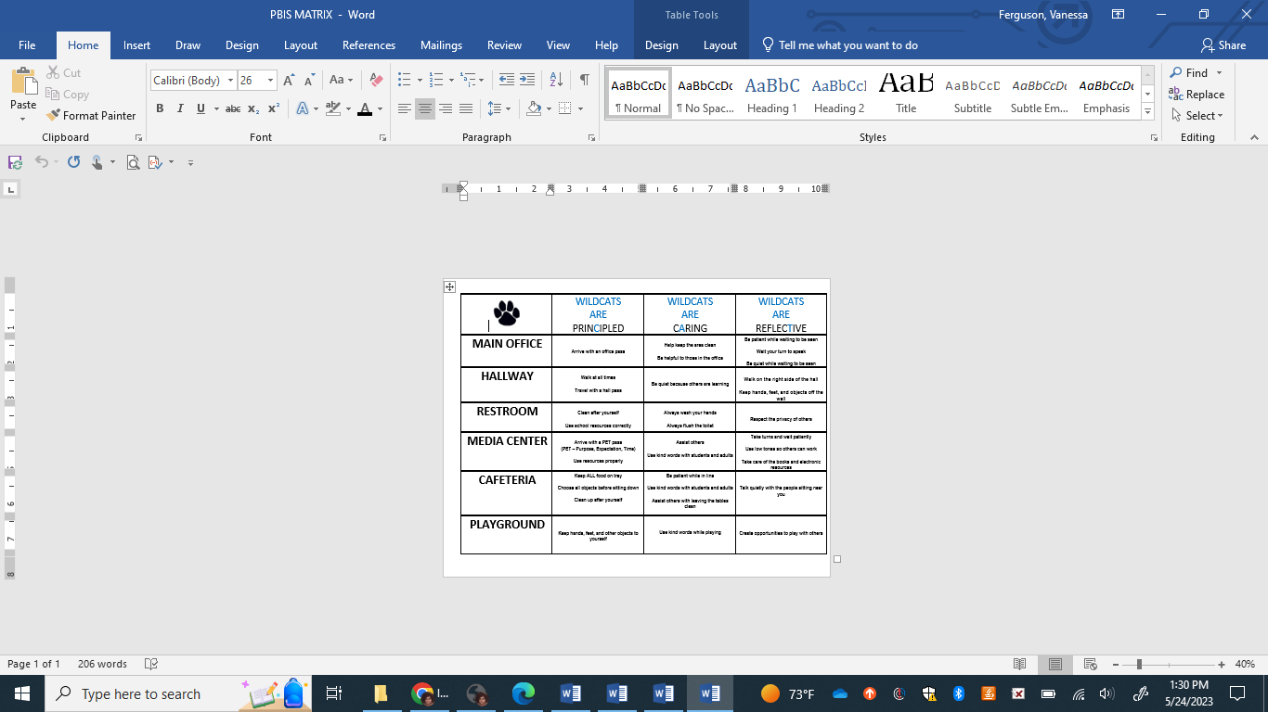

PBIS Lesson Plans – Common Areas

MATERIALS: 2-3 adults – Teaching Poster of Hallway Expectations & PBIS Matrix
BE Principled | BE CARING | BE REFLECTIVE
- Walk at all times  - Travel with a hall pass | 1. Be quiet because others are learning | 1. Walk on the right side of the hall  2. Keep hands, feet, and objects off the wall

TEACH
A. Overview of the lesson: “Today we are going to talk about how ‘we are principled, caring, and reflective in the hallway.”
B. Guided Discovery: “Could someone tell us what we are going to learn an practice today & why we are looking at the Copeland Behavior Matrix?”
C. See above matrix for expectations.
1. Show the Teaching Poster of Expectations with pictures and walk through the expectations.
2. Discuss the detail of the expectations with students.
MODEL
A. Demonstrate examples of not following expectations.
1. Principled – Show example of not facing front, running, and not having a hall pass. Talk with students about how else a person might not be following the Principled expectation in the hallway.
2. Caring - Show example of yelling and playing in the hallway. Talk with students about how a person might not be following the caring expectation in the hallway. Ask students why it is important to be caring in the hall and how it can positively and negatively affect students in other classrooms.
3. Reflective- Show example of not walking on the right, but on the left. Talk with students about why it’s important to keep hands, feet, and objects off of the wall.
B. Choose a couple of students to “show” examples of being principled, caring, and reflective
C. Discussion. “Tell me what “Principled, Caring, and Reflective looks, feel, or sound like in the hall
PRACTICE
A. Have all students line up on the right side of the hallway and have them walk down a hallway and back. monitoring.
B. Debrief with students any questions. “Are there any questions you have about being principled, caring or reflective in the hallway?”

AREA: RESTROOM (Boys at the Boys Restroom and Girls at the Girls Restroom) TIME ALLOTTED: 15-20 minutes
MATERIALS: 2-3 Adults – Teaching Poster of Restroom Expectations & PBIS Matrix
BE Principled | BE CARING | BE REFLECTIVE
1. Clean up after yourself  2. Use school resources correctly | 1. Always wash your hands  2. Always flush the toilet | 1. Respect the privacy of others
TEACH
A. Overview of the lesson: “Today we are going to talk about how ‘we are principled, caring, and reflective in the restroom.”
B. Guided Discovery: “Could someone tell us what we are going to learn and practice today?”
C. See above matrix for expectations & Restroom poster (that is placed outside of each restroom).
1. Show the Teaching Poster of Expectations with pictures and walk through the expectations.
2. Discuss the detail of the expectations with students.
MODEL
A. Demonstrate examples of not following expectations.
1. Principled – Show example of not cleaning up the space (throw paper towel on the floor, smear soap on the mirror), and showing examples of not using school resources correctly (placing toilet tissue on the floor or using too much, using too much soap, or playing with the hand dryer) Talk with students about how else a person might not be following the Respectful expectation in the restroom.
2. Caring- Show example of not washing hands after using the restroom. Ask students why it is important to flush the toilet before leaving the stall/urinal. Talk with students about how else a person might not be following the Caring expectation in the restroom.
3. Reflective - Show example of not respecting the privacy of others. Talk with students about how else a person might not be following the Reflective expectation in the restroom.
B. Choose a couple of students to “show” examples of following the expectations.
1. Principled– Show an example for cleaning up their space (i.e., throw paper towel away after washing hands) and using school resources correctly (i.e., picking up trash off the floor, using once push of soap, using hand dryer until hands are dry then stepping away).
2. Caring – Show an example of washing your hands & flushing the toilet.
3. Reflective– Show an example of respecting the privacy of others.
C. Discussion. “Tell me what “Principled, Caring, and Reflective look, feel, or sound like in the restroom.”

PRACTICE
A. Have all students line up outside the restroom, and two at a time come into the restroom to show the following of the restroom expectations with an adult monitoring.
B. Debrief with students any questions. “Are there any questions you have about being principled, caring, and reflective behavior in the restroom?”

AREA: MEDIA CENTER TIME ALLOTTED: 15-20 minutes
MATERIALS: 2-3 Adults – Teaching Poster of Media Center Expectations
BE Principled | BE CARING | BE REFLECTIVE
- Arrive with a PET Pass (PET – purpose, expectation, and time)  - Use resources properly | 1. Assist others  2. Use kind words with students and adults | 1. Take turns and wait patiently  2. Use low tones so others can work  3. Take care of books and electronic resources

TEACH
A. Overview of the lesson: “Today we are going to talk about how ‘we are respectful, responsible, and safe in the media center.”
B. Guided Discovery: “Could someone tell us what we are going to learn and practice today?”
C. See above matrix for expectations.
1. Show the Teaching Poster of Expectations with pictures and walk through the expectations.
2. Discuss the detail of the expectations with students.
MODEL
A. Demonstrate examples of not following expectations.
1. Principled – Show example of not following directions (i.e. forgetting to take a PET pass, not using a shelf marker, throwing books on the floor, etc.). Talk with students about how else a person might not be following the Principled expectation in the media center.
2. Caring - Show example of not assisting others (being mean to other students, not being a good example and following expectations), not using kind words to adults and students (i.e., yelling or talking over someone)
3. Reflective - Show example of not taking turns and waiting patiently (i.e., jumping to the front of the line or telling others to move and get out of your way), not using low tones (i.e., yelling or singing loudly). Not taking care of books and other electronic resources (throwing them on the floor)
B. Choose a couple of students to “show” examples of following the expectations.
1. Principled – Show an example for following directions (taking and giving the media specialist the PET pass, using resources correctly – using a shelf marker and using resources properly).
2. Caring – Show an example assisting others in the media center. Also showing using kind and helpful words to students and adults.
3. Reflective – Show an example of taking turns and waiting patiently. Also using low tones to not disturb other students, while taking care of books and other resources in the media center.
C. Discussion. “Tell me what “Principled, Caring, and Reflective look, feel, or sound like in the media center.”
PRACTICE
A. All students are to roam the media center and check out a book using the expectations, with an adult monitoring.
B. Debrief with students any questions. “Are there any questions you have about being principled, caring, and reflective behavior in the media center?” (Practice could be done during the first “check out” time in the media center)

AREA: MAIN OFFICE TIME ALLOTTED: 15-20 minutes
MATERIALS: 2-3 Adults – Teaching Poster of Main Office/Health Office Expectations
BE Principled | BE CARING | BE REFLECTIVE
1. Arrive with an office pass. | 1. Help keep the area clean  2. Be helpful to those in the office. | - Be patient while waiting to be seen.  - Wait your turn to speak.  - Be quiet while waiting to be seen.

TEACH
A. Overview of the lesson: “Today we are going to talk about how ‘we are principled, caring, and reflective in the main office.”
B. Guided Discovery: “Could someone tell us what we are going to learn and practice today?”
C. See above matrix for expectations.
1. Show the Teaching Poster of Expectations with pictures and walk through the expectations.
2. Discuss the detail of the expectations with students.
MODEL A. Demonstrate examples of not following expectations.
1. Principled – Show example of not being principled by not having a hall pass. Talk with students about how else a person might not be following the Respectful expectation in the main office/health office.
2. Caring - Show example of not being caring – not keeping the area clean (i.e. throwing paper on the floor in the office). Show example of not being helpful to those in the office (i.e. being rude or yelling at an adult when they ask you a questions).
3. Reflective – Show an example of not being patient while waiting to be seen (i.e. being sarcastic to an adult), not waiting your turn to speak (i.e. speaking over an adult in the office), and not being quiet while waiting to be seen.
B. Choose a couple of students to “show” examples of following the expectations.
1. Principled– arriving to the office with a pass.
2. Caring – Show an example of helping to keep the office area clean and being helpful to those in the office
3. Reflective – Show and example of being patient while waiting to be seen, waiting your turn to speak, and being quiet while waiting to be seen.
PRACTICE
A. Students line up outside the office and one at a time come into the office with a pass or note and use the expectations for
this area, with adult monitoring.
B. Debrief with students any questions. “Are there any questions you have about being principled, caring, and reflective behavior in the main office/health office?”

AREA: LUNCHROOM TIME ALLOTTED: 15-20 minutes
MATERIALS: 2-3 Adults – Teaching Poster of Lunchroom Expectations
BE Principled | BE CARING | BE REFLECTIVE
- Keep ALL food on tray.  - Choose all objects before sitting down.  - Clean up after yourself. | - Be patient while in line.  - Use kind words with students and adults.  - Assist others with leaving the table clean. | 1. Talk quietly with the people sitting near you.

TEACH
A. Overview of the lesson: “Today we are going to talk about how ‘we are respectful, responsible, and safe in the lunchroom.”
B. Guided Discovery: “Could someone tell us what we are going to learn and practice today?”
C. See above matrix for expectations.
1. Show the Teaching Poster of Expectations with pictures and walk through the expectations.
2. Discuss the detail of the expectations with students.
MODEL
A. Demonstrate examples of not following expectations.
1. Principled – Show example of not throwing food and not keeping all food on tray. Not choosing objects before sitting down – getting back up to get something that they forgot. Also, show example of not cleaning up after yourself – throwing food or not picking up items that have fallen on the table. Talk with students about how else a person might not be following the Principled expectation in the lunchroom.
2. Caring - Show example of not being patient while in line – yelling at cafeteria staff or other students. Not using kind words with students and adults. Also, not assisting others with leaving the tables clean – not picking up after yourself. Talk with students about how else a person might not be following the Caring expectation in the lunchroom.
3. Reflective - Show example of yelling and not talking quietly with people near you at your table. Talk with students about how else a person might not be following the Safe expectation in the lunchroom.
B. Choose a couple of students to “show” examples of following the expectations.
1. Principled– Show an example of keeping ALL food on trays, choosing all objects before sitting down, and cleaning up after yourself.
2. Caring – Show an example of being patient while waiting in line, using kind words with students and adults in the cafeteria, and assisting others with leaving the table clean.
3. Reflective – Show an example of talking quietly with the people sitting near you.
C. Discussion. “Tell me what “Principled, Caring, and Reflective look, feel, or sound like in the lunchroom.”
PRACTICE
A. Students enter the lunchroom and follow the expectations all of the way through, with an adult monitoring.
B. Debrief with students any questions. “Are there any questions you have about being principled, caring, and reflective behavior in the lunchroom?”

AREA: PLAYGROUND
TIME ALLOTTED: 15-20 minutes
MATERIALS: 2-3 Adults – Teaching Poster of Playground Expectations
BE Principled | BE CARING | BE REFLECTIVE
1. Keep hands, feet, and other objects to self. | 1. Use kind words while playing. | 1. Create opportunities to play with others.

TEACH A. Overview of the lesson: “Today we are going to talk about how ‘we are respectful, responsible, and safe in the classroom.”
B. Guided Discovery: “Could someone tell us what we are going to learn and practice today?”
C. See above matrix for expectations.
1. Show the Teaching Poster of Expectations with pictures and walk through the expectations.
2. Discuss the detail of the expectations with students.
MODEL
A. Demonstrate examples of not following expectations.
1. Principled – Show example of not keeping hands feet, and other objects to self. Talk with students about how else a person might not be following the Respectful expectation on the playground.
2. Caring - Show example of not using kind words while playing on the playground. Talk with students about how else a person might not be following the Responsible expectation on the playground.
3. Reflective - Show example of not creating opportunities to play with others. Talk with students about how else a person might not be following the Safe expectation on the playground.
B. Choose a couple of students to “show” examples of following the expectations.
1. Principled – Show an example for sharing and taking turns (i.e., say “would you like to swing now”), including others in play (i.e., “would you like to play a game with us”), and follow directions (i.e., go to the wall when directed to from an adult).
2. Caring – Show an example of bringing in what you take out (i.e., pick up a ball in the field to carry), lining up quickly and quietly (i.e., run to line up on the whistle).
3. Reflective – Show an example of walking on the sidewalk (i.e., walk on sidewalk around courtyard), stay on the playground (i.e., ball rolls into the parking lot ask to go get the ball), and using only playground equipment (i.e., playing with basketball).
C. Discussion. “Tell me what “Principled, Caring, and Reflective look, feel, or sound like on the playground.”

PRACTICE
A. Students enter the lunchroom and follow the expectations all of the way through, with an adult monitoring.
B. Debrief with students any questions. “Are there any questions you have about being principled, caring, and reflective behavior on the playground?”

System for Acknowledging Behavior
- Positive, specific verbal praise
- Adults in the building acknowledge students following behavior expectation (principled, caring, and reflective) with PBIS points on the PBIS Rewards App.
- PBIS Wildcat Store – students can purchase items, with PBIS points. There are a variety of items from 5 points up to 150 points.
- PBIS Monthly Celebrations – Each month students with 75 points can come to the PBIS Celebration. Some examples of previous PBIS celebrations are: dance parties, outside play time, game day, etc.

Correcting Behavior
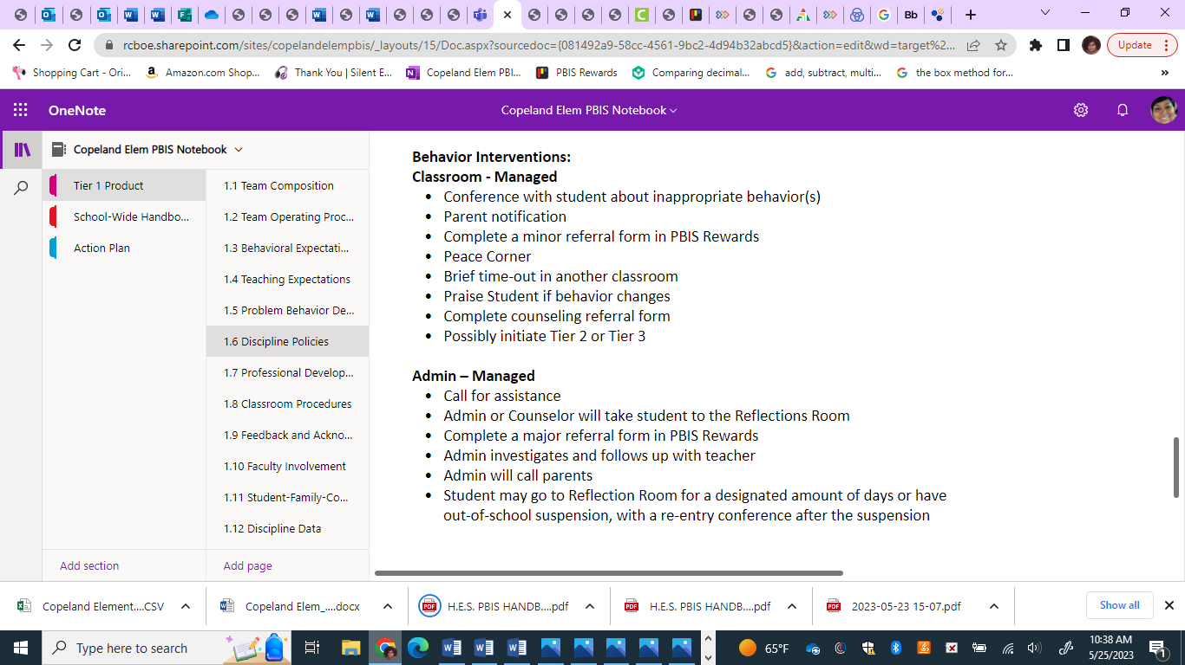

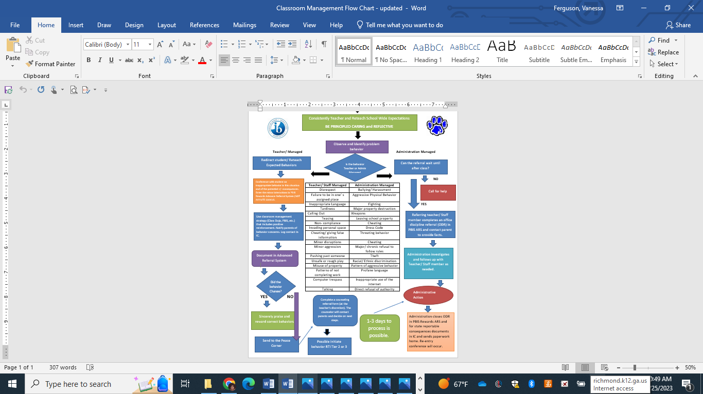

Discipline Referrals:
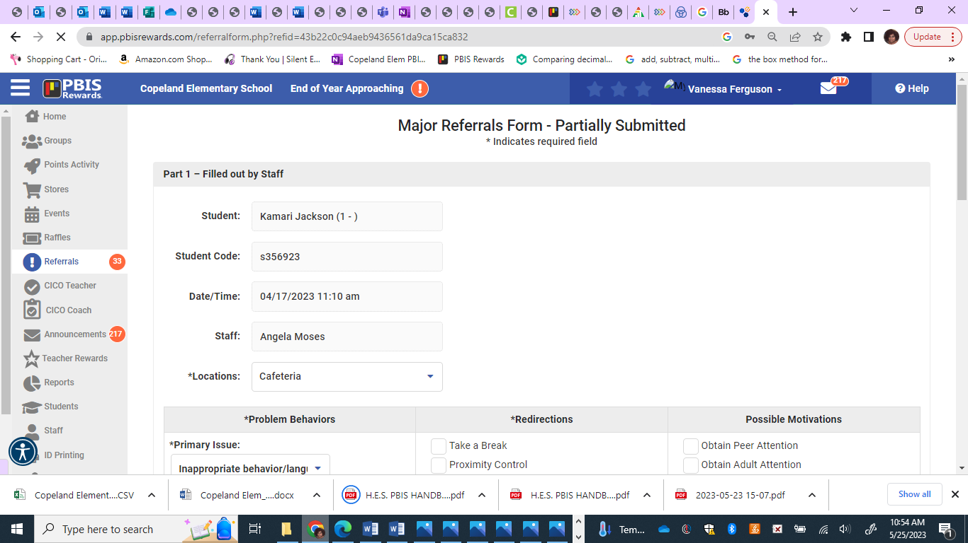

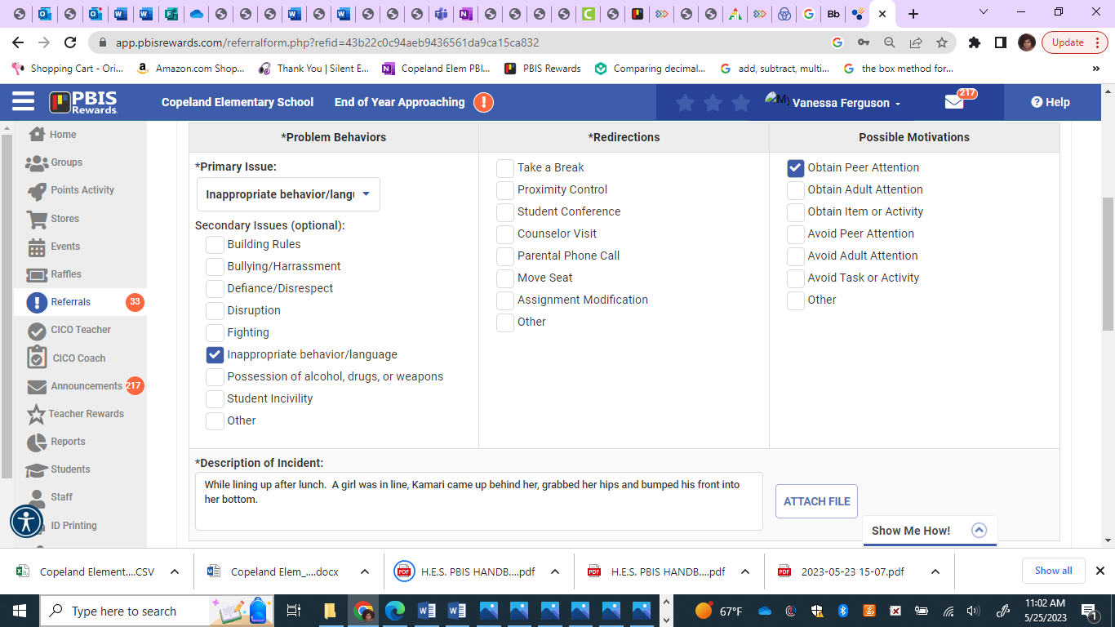

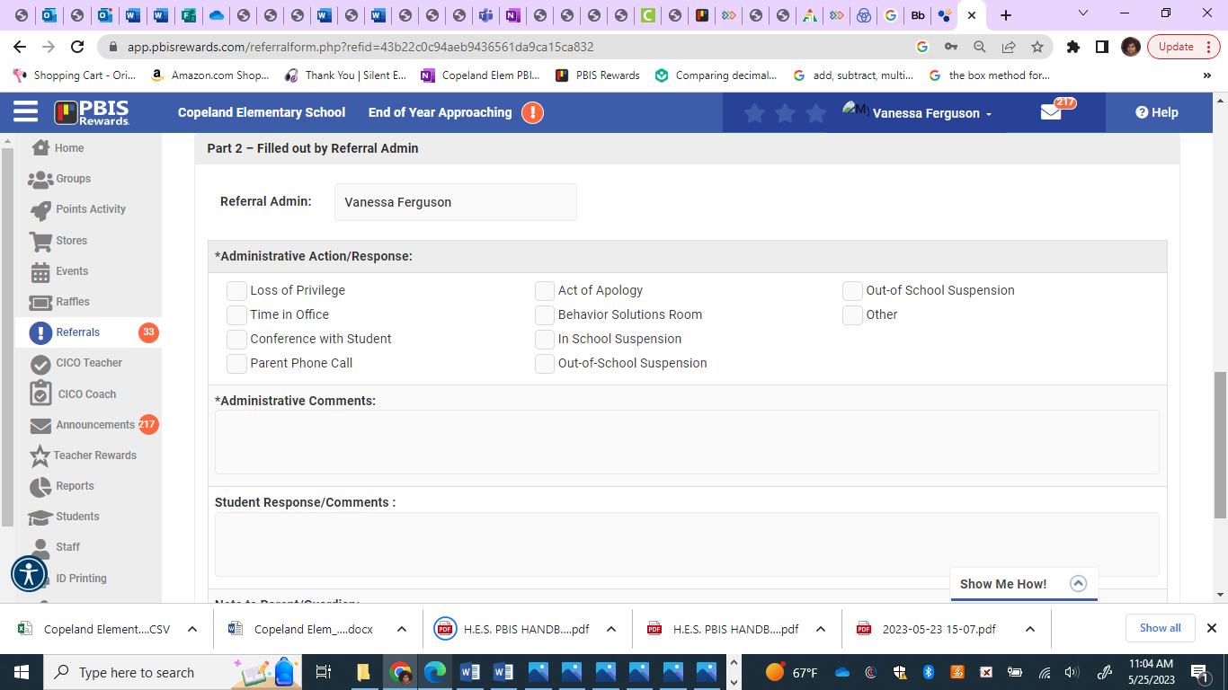

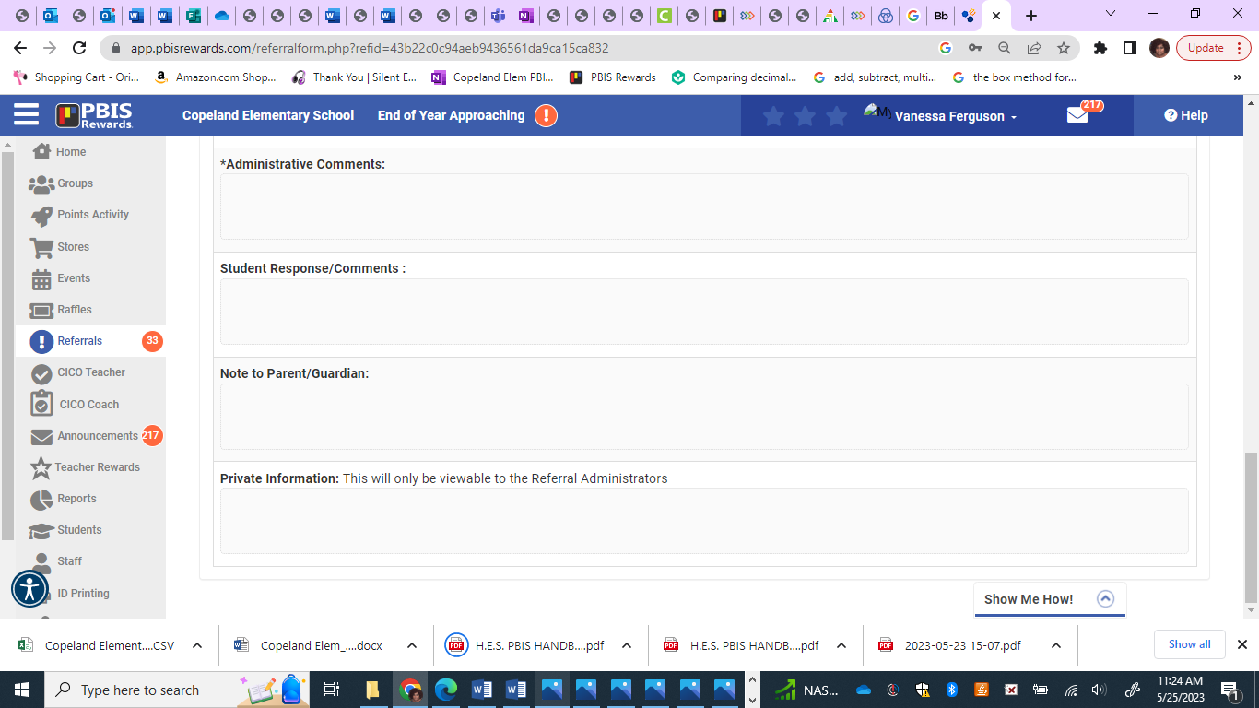

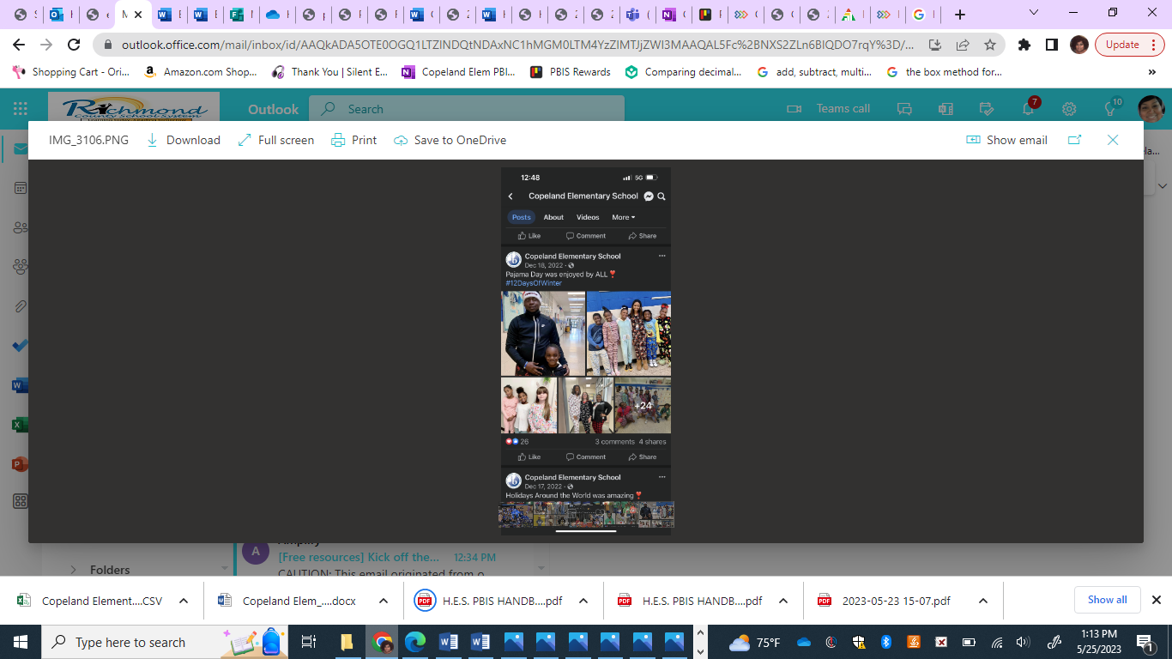
PBIS & School Climate
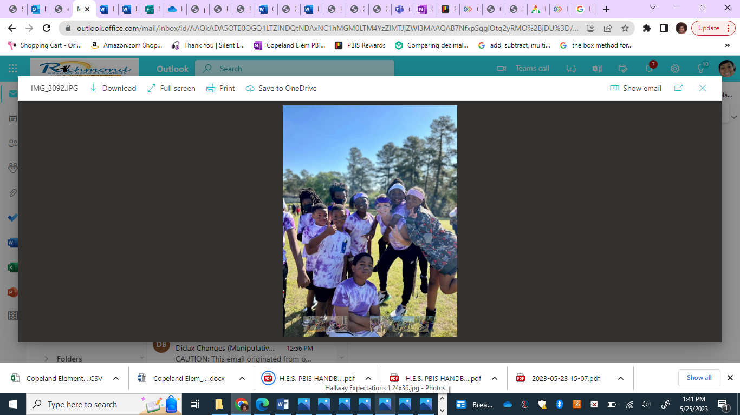
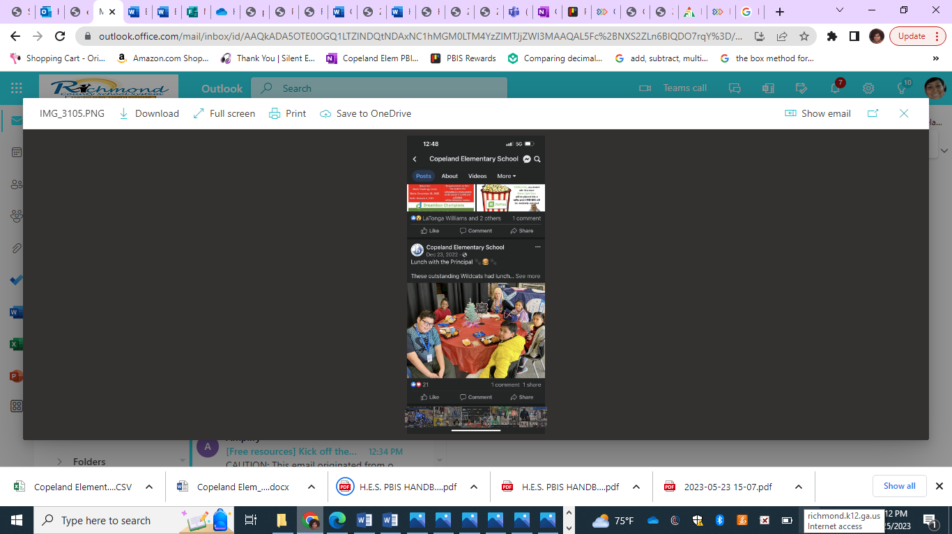
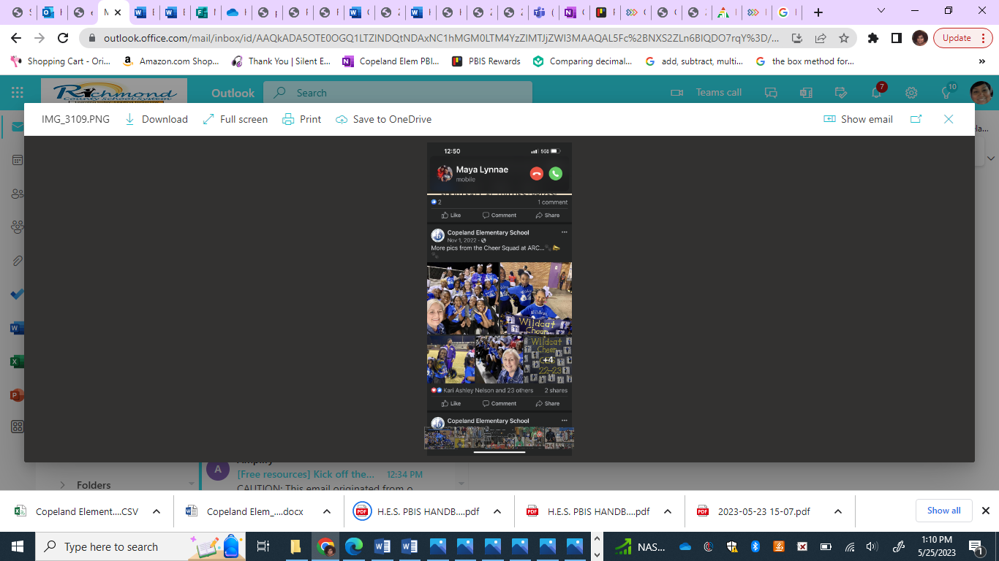

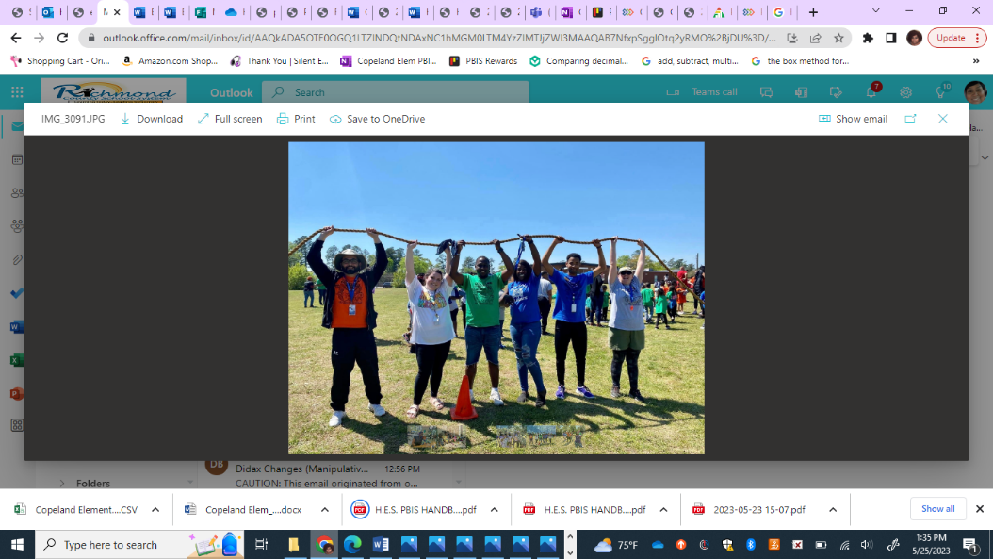

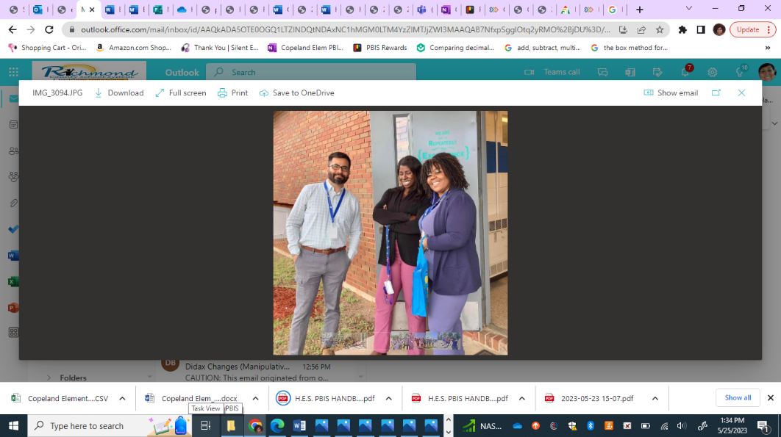
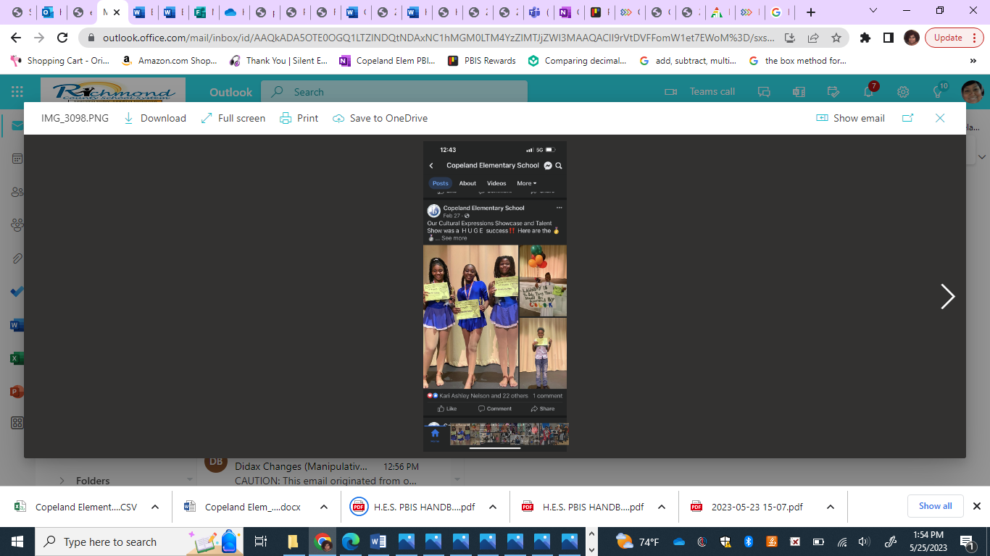
“Through your PBIS implementation, you’ll engage your school-wide community to co-create your school’s culture and establish a climate where everyone feels welcome and seen. In fact, when schools implement PBIS, teachers, students, and their families all perceive their school’s climate more positively.”
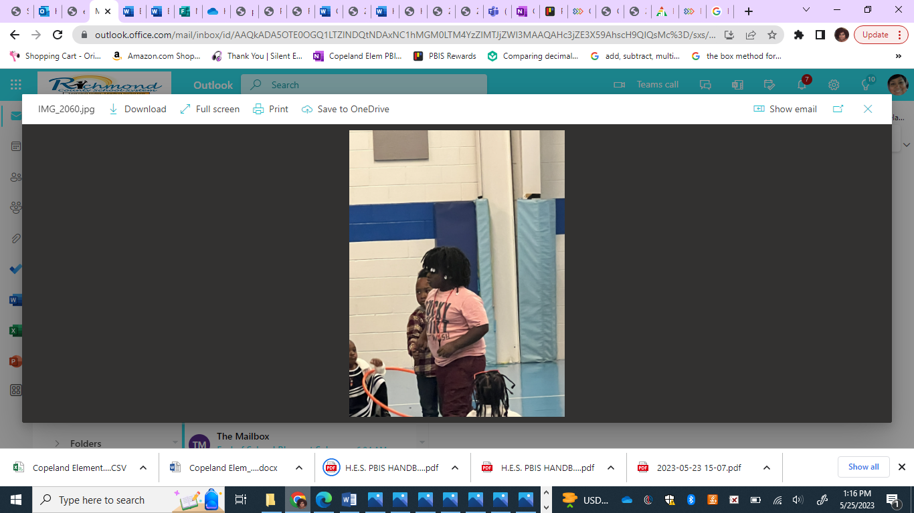
-pbis.org

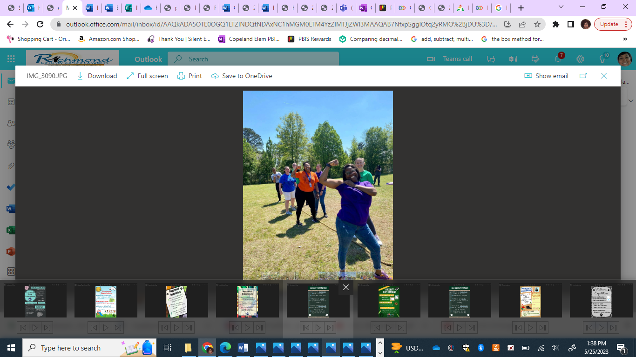
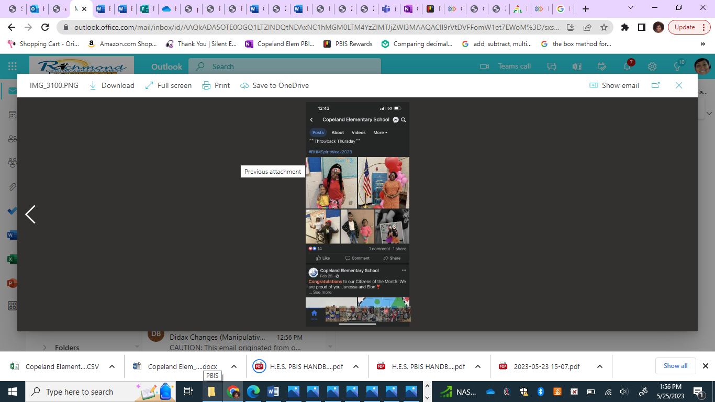
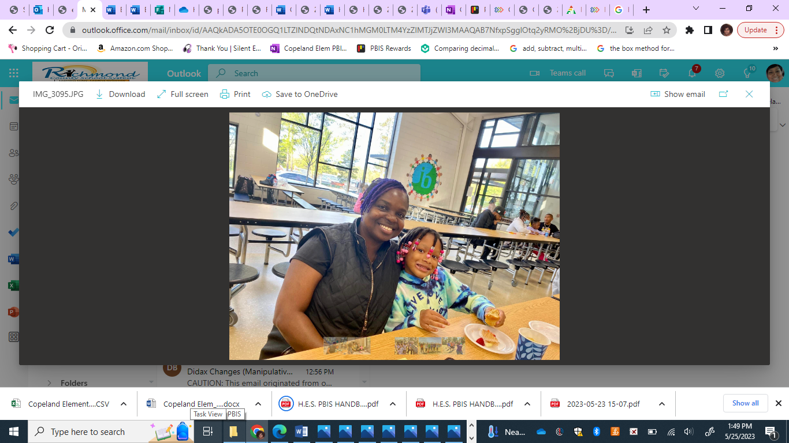
Copeland… what a great place to be!
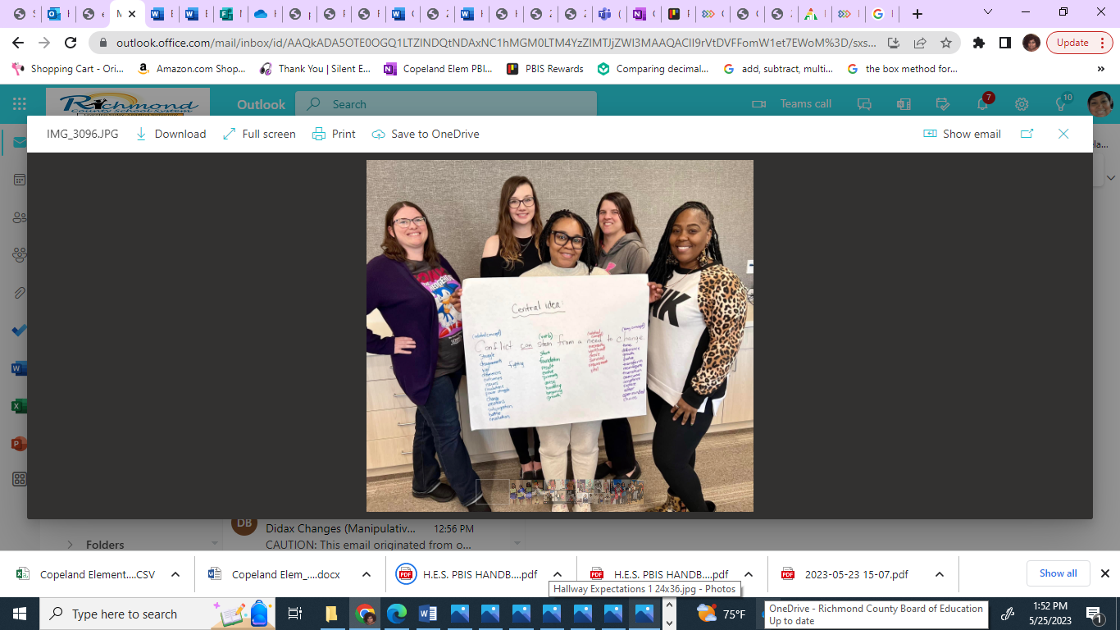

References

pbis.org
https://sebacademy.edc.org/pbis-track
pbisrewards.com

